**TRAINING: TECH NINJA**

**Table of Content**

1. Introduction
2. Requirements
   1. Software Requirement

## Prerequisite

1. Sitemap
   1. Training Site
   2. Home Page
   3. Courses
2. Wireframe
   1. Home Page
   2. About Page
   3. Contact Page
3. Project Structure
   1. Frontend
4. System Module

**Introduction**

* A simple website layout which have basic Home Page, About Us Page, Contact Page, login Page, Payment Page and so on.
* A simple homepage design welcomes our audience to our site, tells them what we want them to do next, and allows them to explore our site in more depth.
* About us page is all about to tell the introduction about company, company’s leaders, professionals as well as team.
* There are Contact page through which you can reach out the company. A payment page through which you can make payment for a particular course which you wish to learn.
* We can add complexity to a simple homepage design, but we don’t want to start with a cluttered mess and have to selectively prune it. Always begin with the basics.
* What do we need on your homepage? What will your audience expect? And which elements take priority?

**Requirements**

* **Software Requirement**

|  |  |
| --- | --- |
| Operating System | Windows, macOS, Linux |
| Front-End | HTML, CSS, Bootstrap |

## **Prerequisite**

For this objective, you should have knowledge of basics of JavaScript, HTML, CSS, and Bootstrap.

**HTML** - HTML is the standard markup language for Web page, where you can create your own Website.

**CSS** - CSS is the language we use to style an HTML document. It describes how HTML elements should be displayed.

**Bootstrap** –It is the most popular HTML, CSS, and JavaScript framework for developing responsive, mobile-first websites.

**Sitemap**

A sitemap is a file where you provide information about the pages, videos, and other files on your site, and the relationships between them.

* Training Sitemap

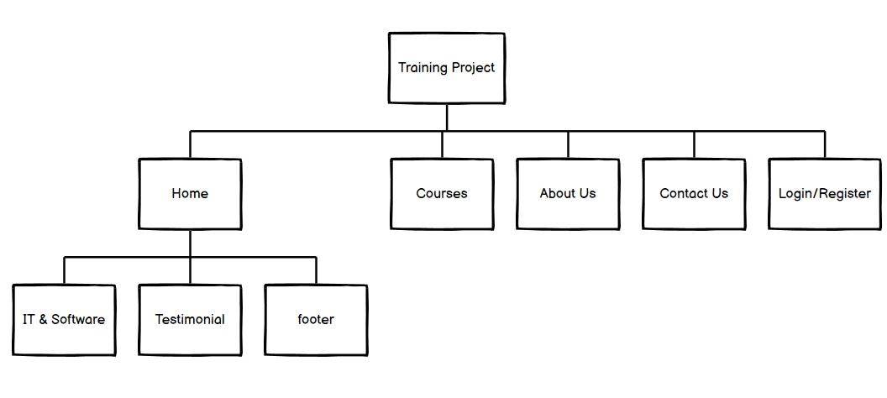

* IT & Software Sitemap

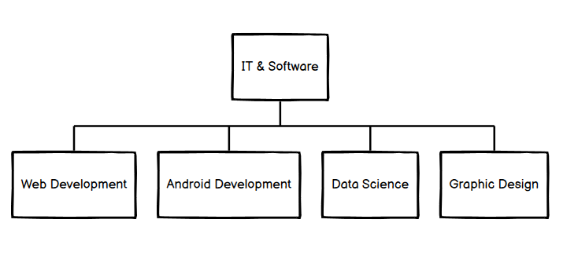

* Courses Sitemap

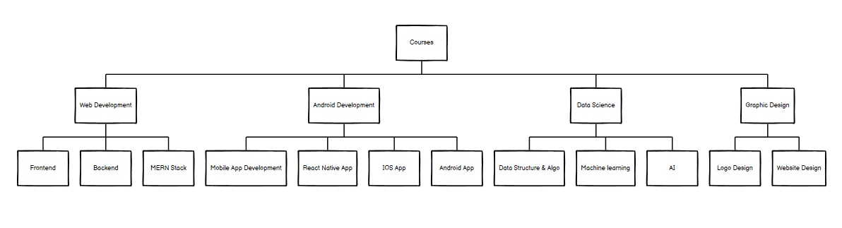

**Wireframe**

A website wireframe, also known as a page schematic or screen blueprint, is a visual guide that represents the skeletal framework of a website. Wireframes are created for the purpose of arranging elements to best accomplish a particular purpose.

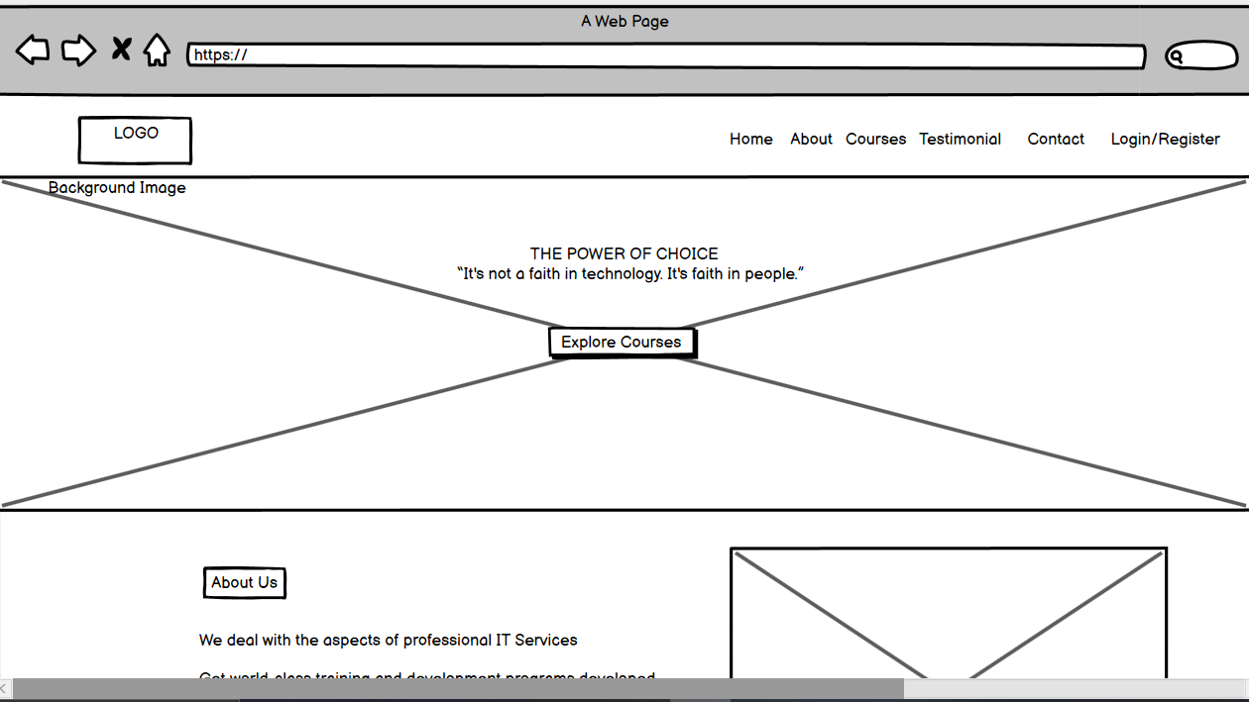

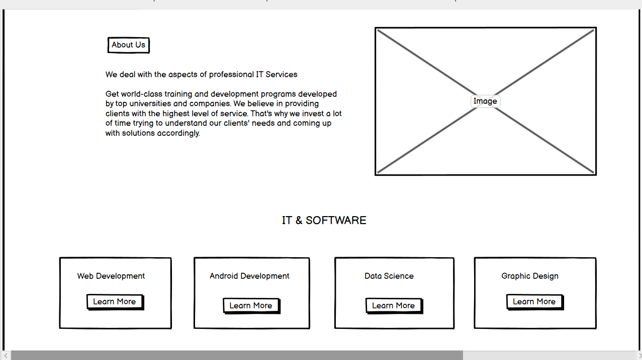

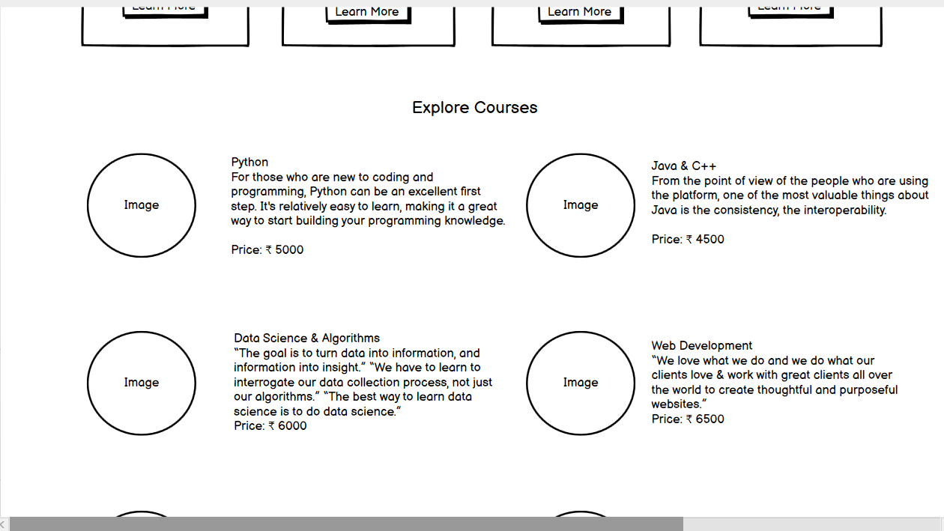

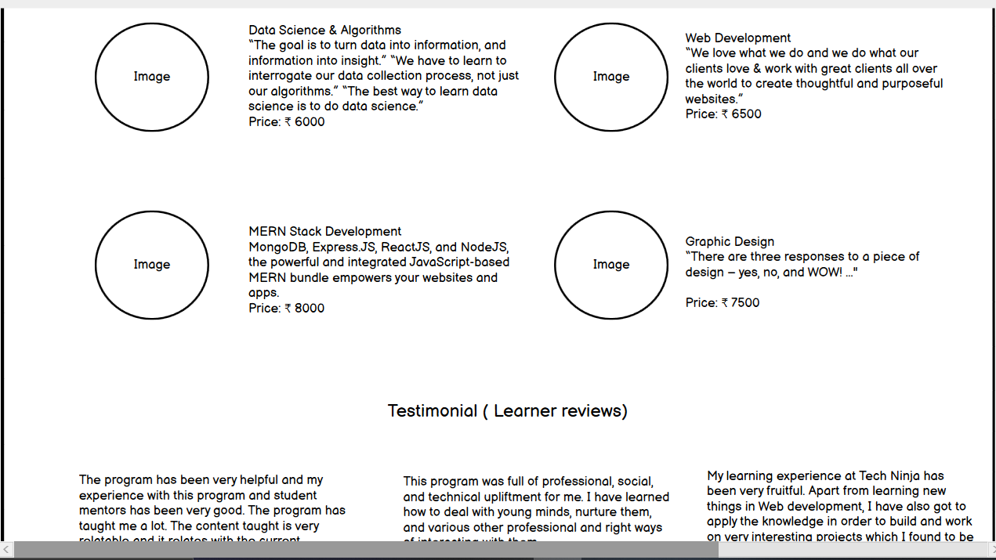

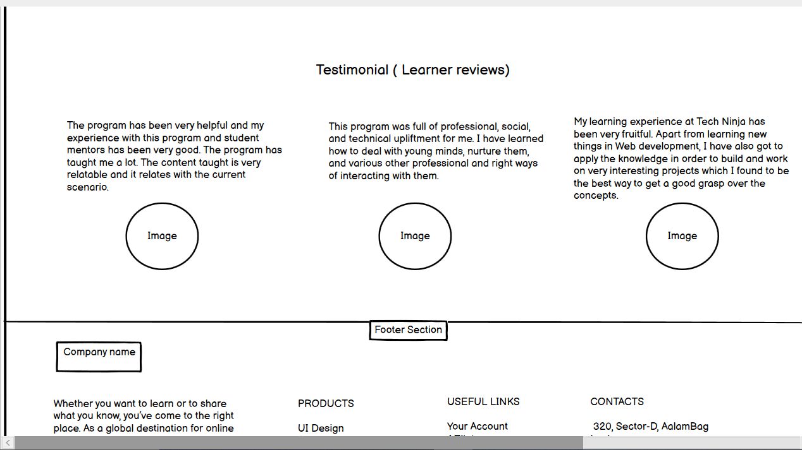



**About Page Wireframe**

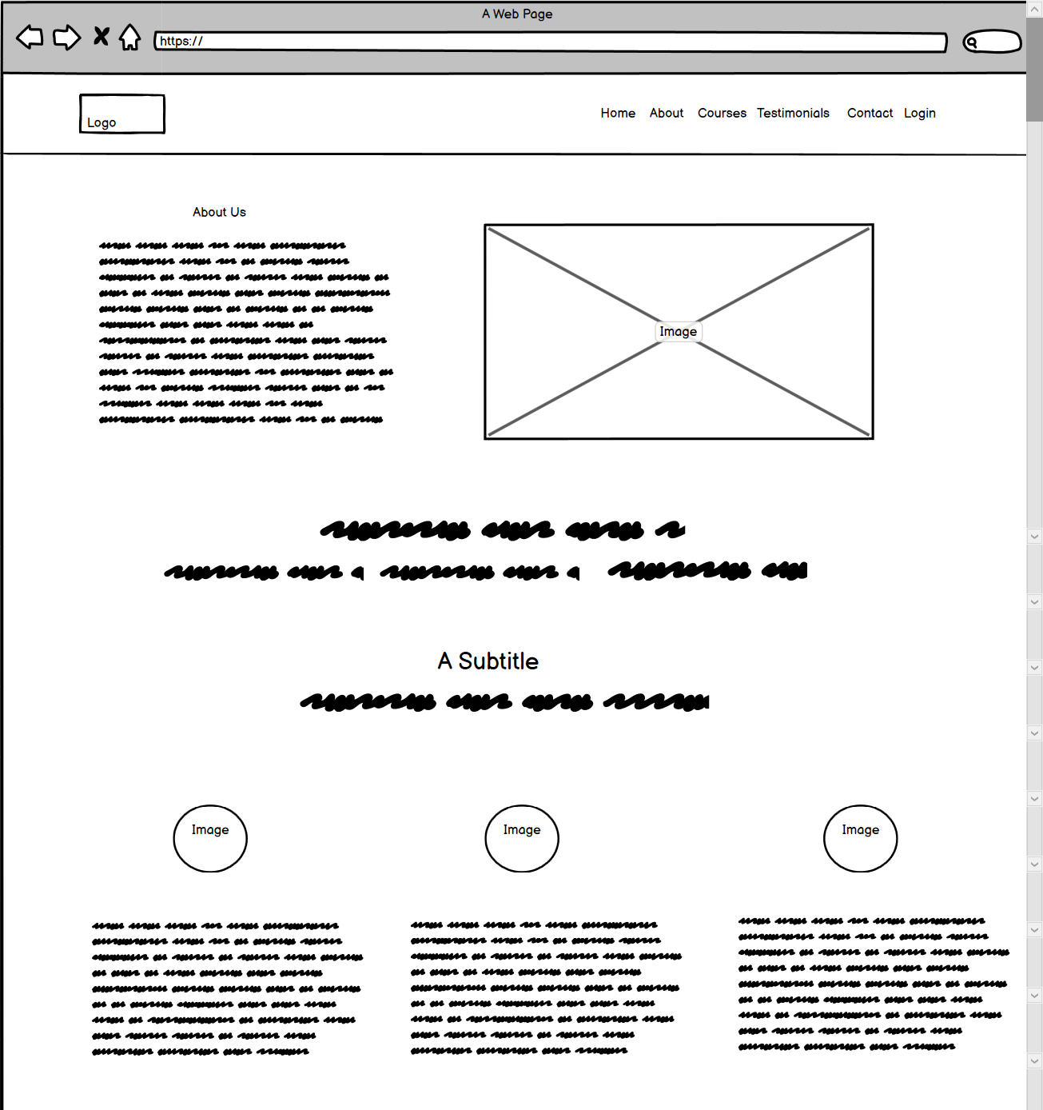

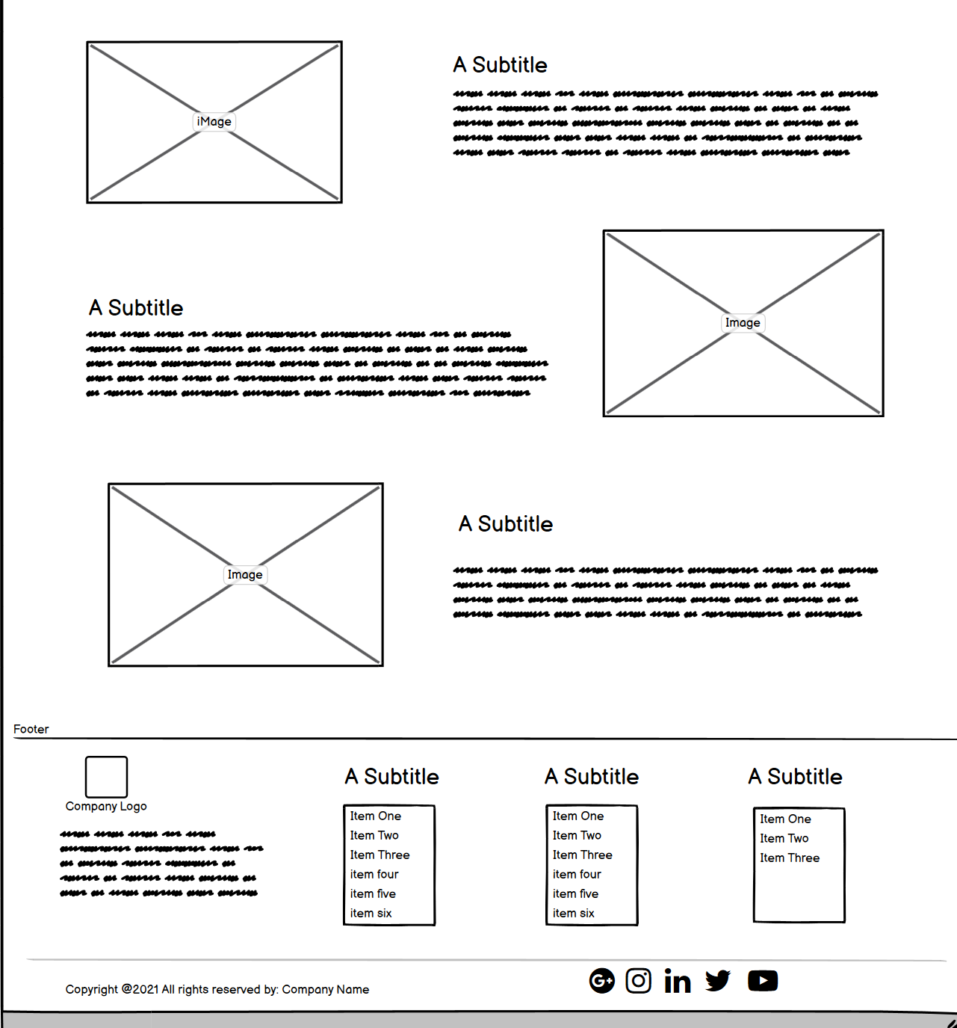

**Contact Page Wireframe**

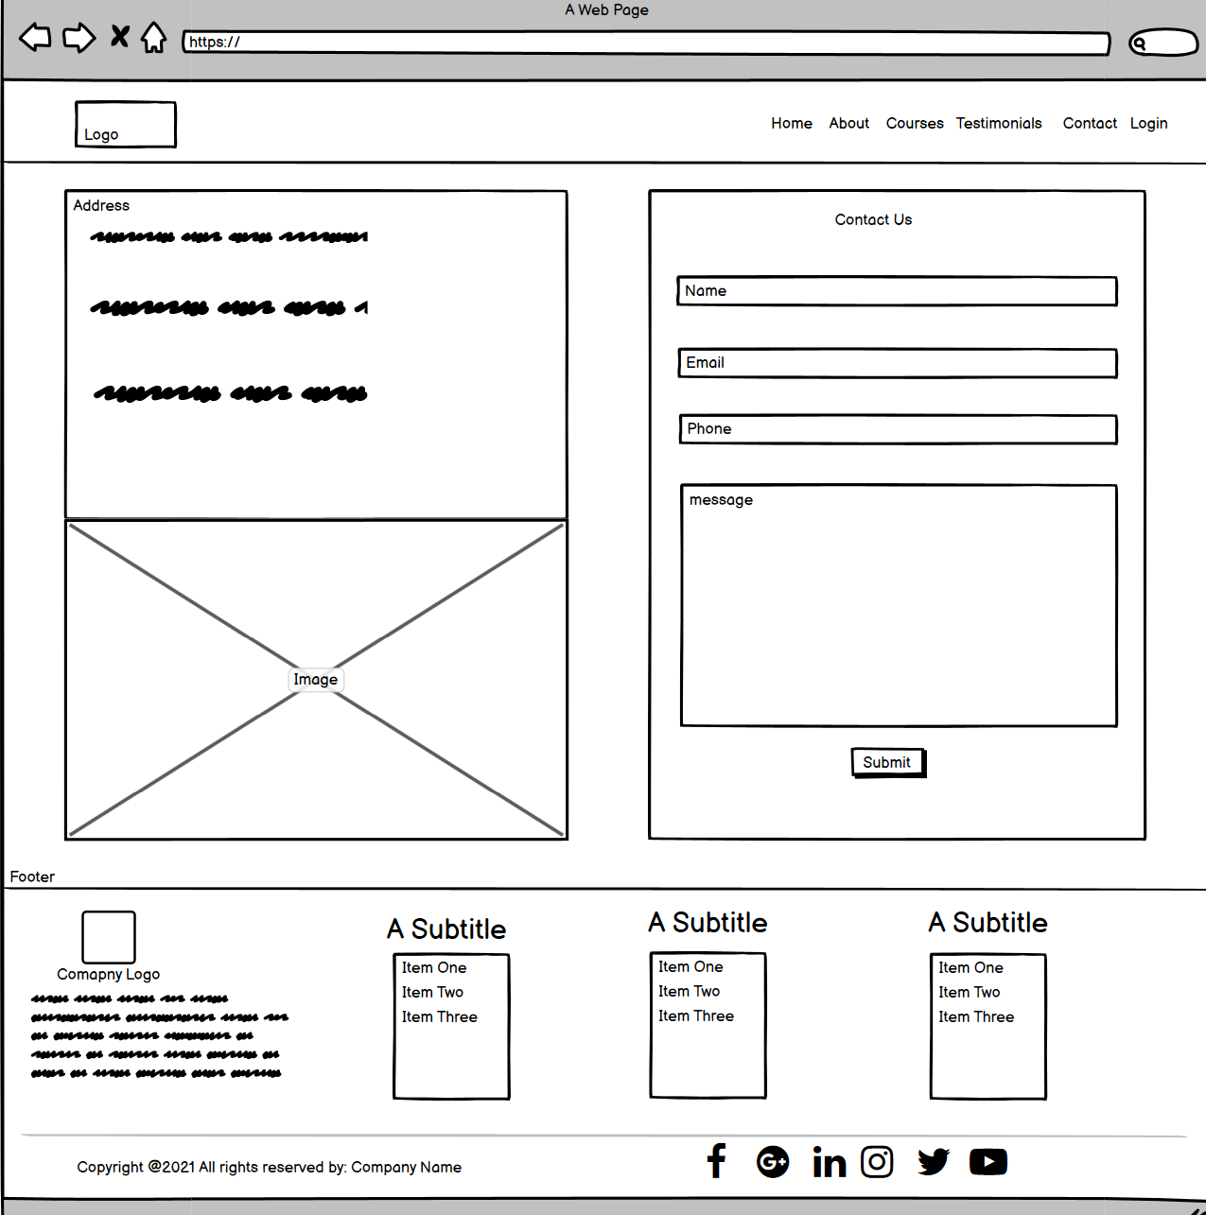

**Project Structure**

* **Frontend**

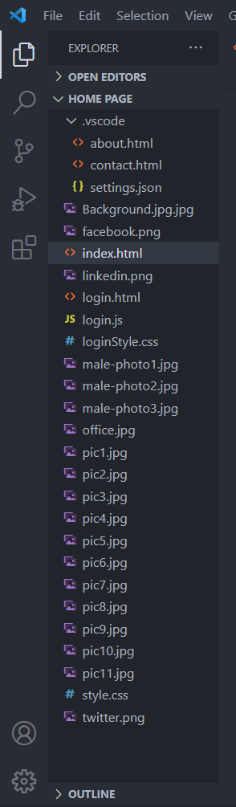

**System Module**

**Home Page Module**















**About Page Module**









**Contact Page Module**

